FIRST SET OF QUESTIONS

Question 1 – Collect three run-time input from user. Add together the first two numbers and then multiply this total by the third. Display the answer as “The answer is :” [answer]

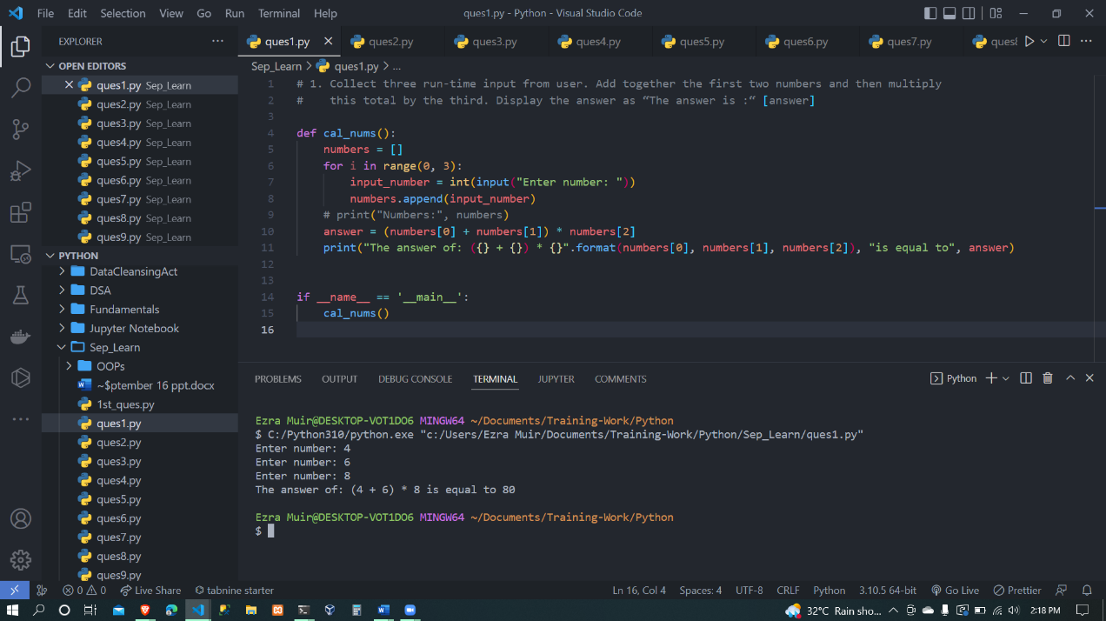

Question 2 - Program to print only the added fraction of any two number {Input: 2.356 3.5678 Output: 0.9238}

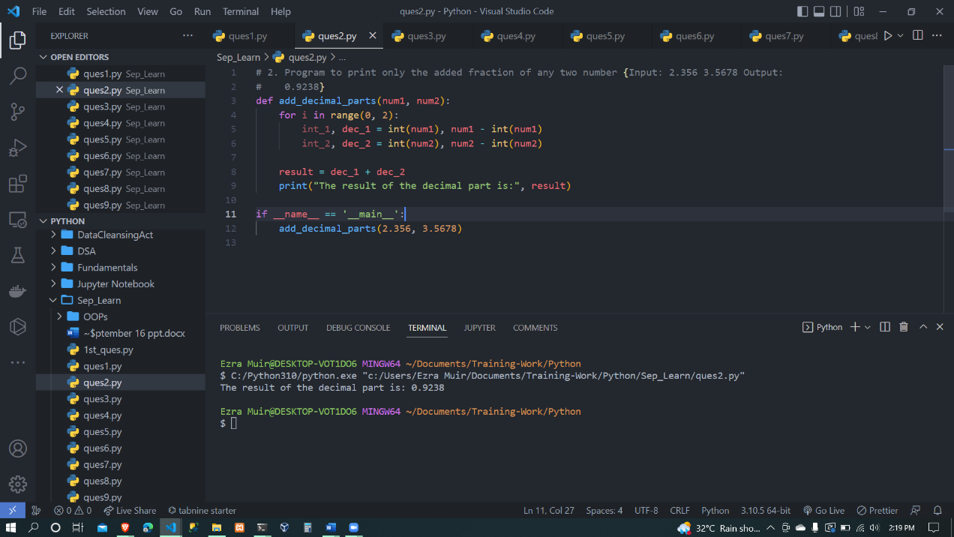

Question 3 - Program to calculate hours, minutes and seconds for a given input days.

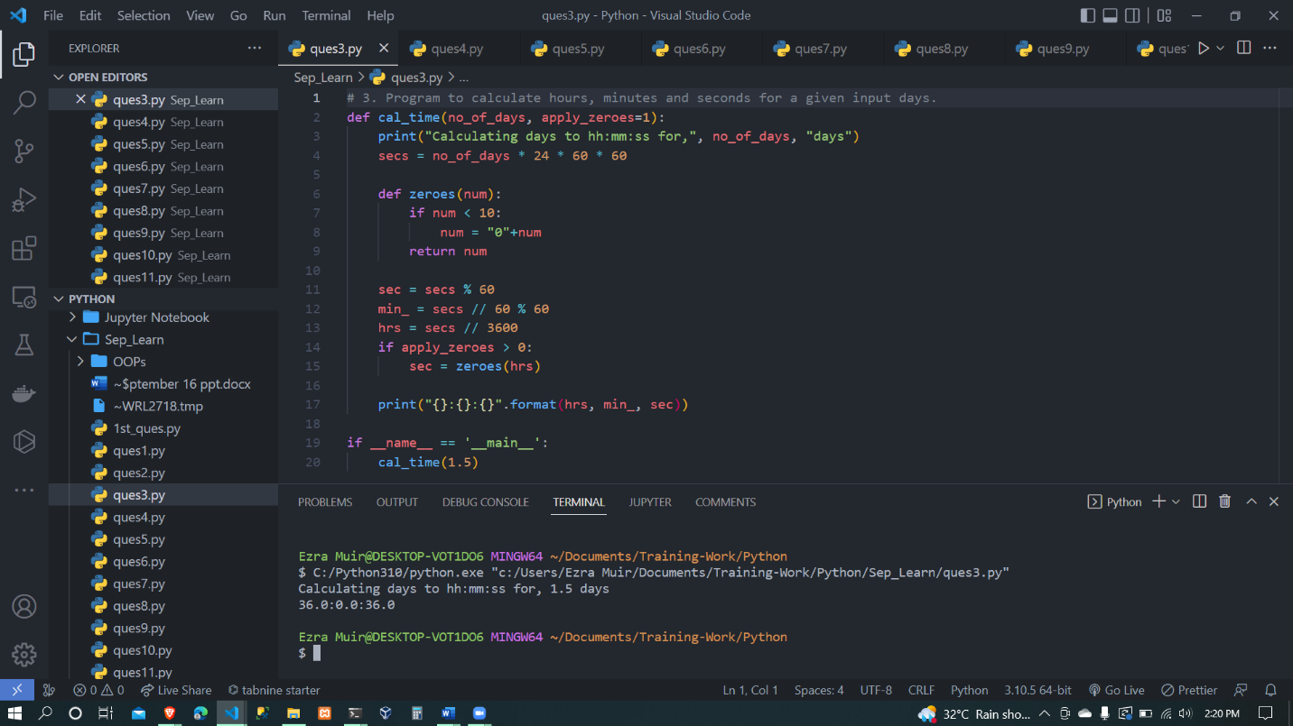

Question 4 - Program to print the unit digit of a given number { Input: 1567 Output: 7}

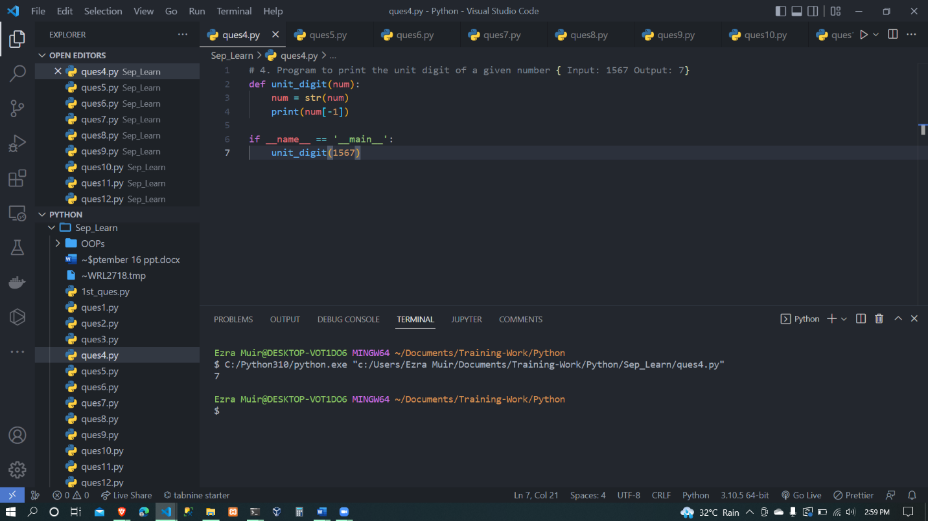

Question 5

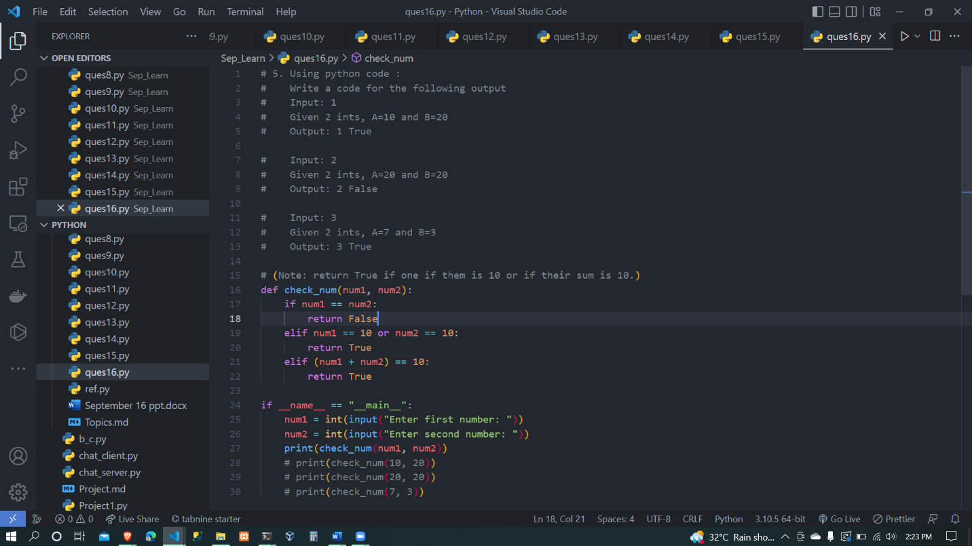

Question 6 – Program to calculate the sum from ‘M’ number to ‘N’ number. {Input: M-5 N-10 Output: 45}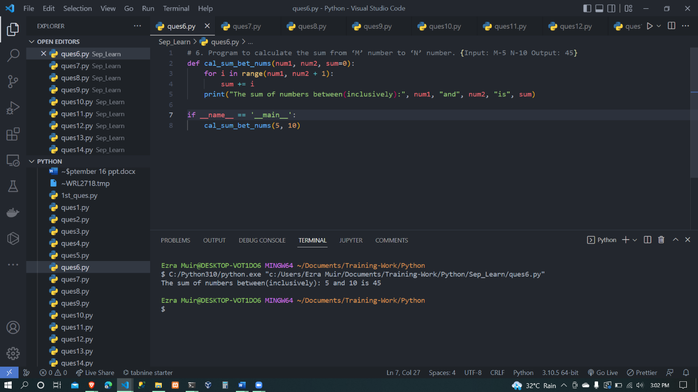

SECOND SET OF QUESTIONS

Question 1 – Calculate CGST and SGST for a product and print the total price to pay {CGST = SGST = 9%}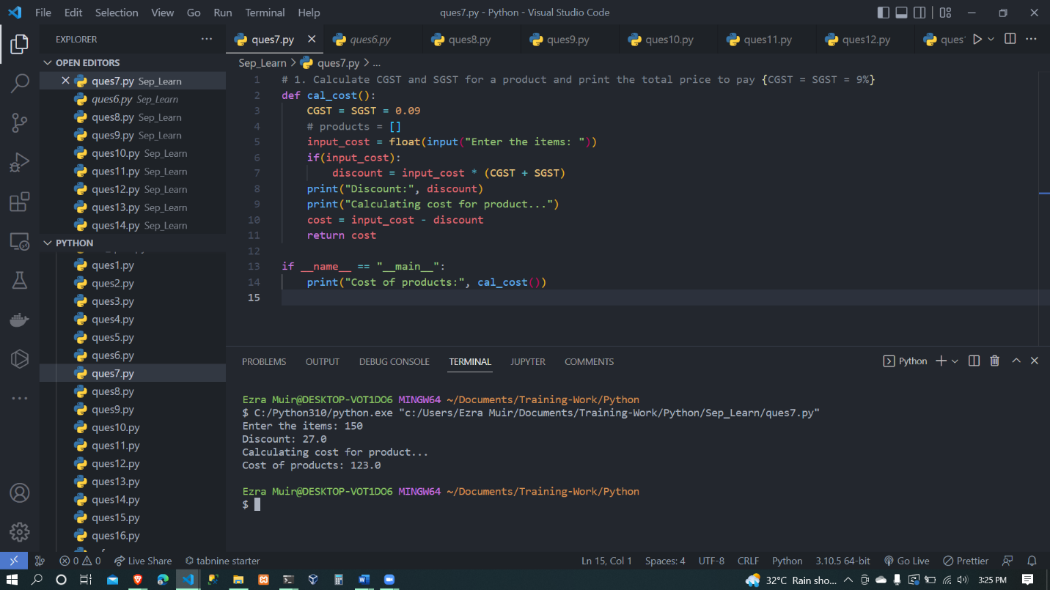

Question 2 – Write a program to read the marks of 5 subjects through the keyboard. Find out the aggregate and percentage of marks obtained by the student. Assume maximum marks that can be obtained by a student in each subject as 100.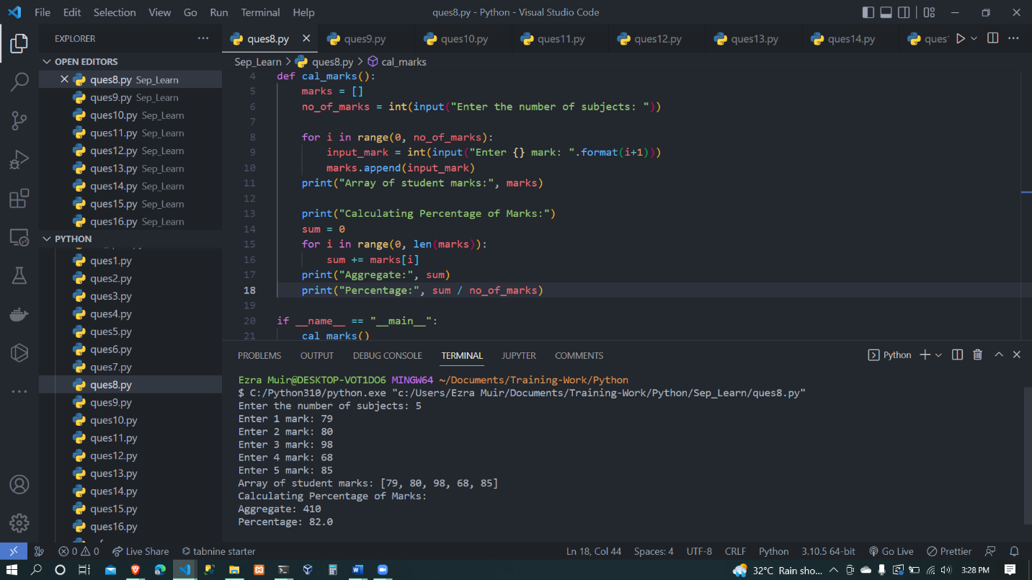

Question 3 – Write a program to read a four-digit number through the keyboard and calculate the sum of its digits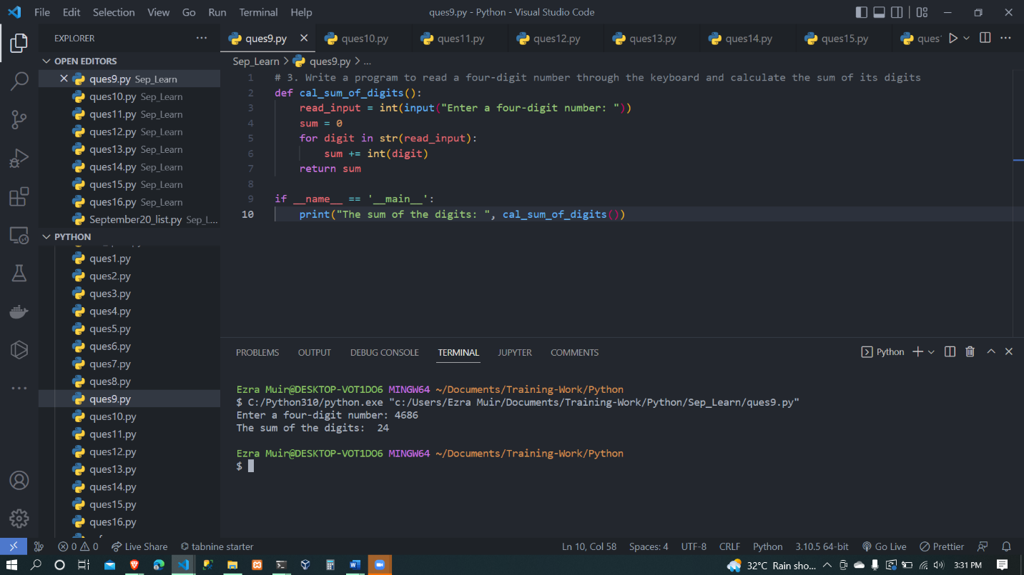

Question 4 – An ATM contains Indian currency notes of 100, 500 and 1000. To withdraw cash from this ATM, the user has to enter the number of notes he/she wants of each currency, i.e. of 100, 500 and 1000. Write a program to calculate the total amount withdrawn by the person from the ATM in rupees.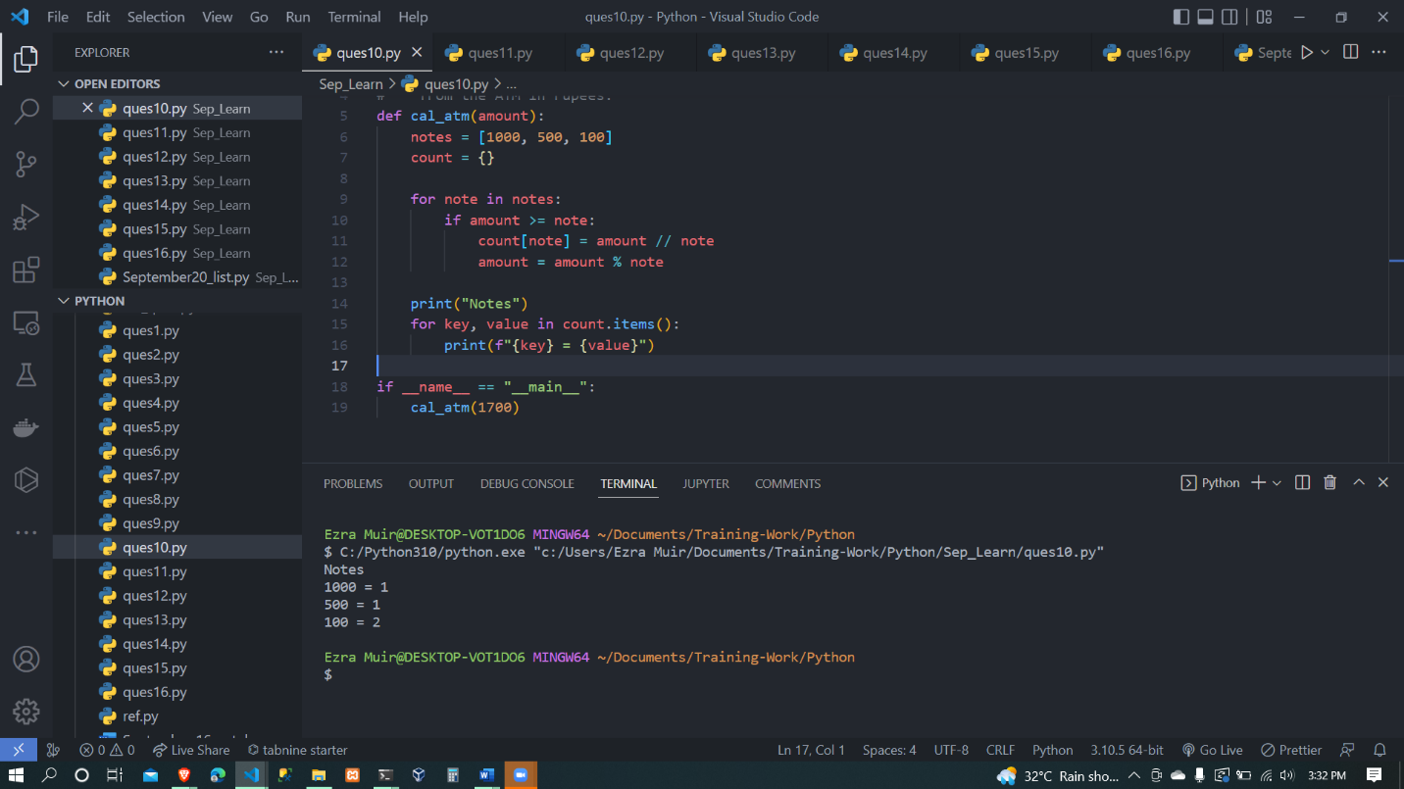

Question 5 - Write a program to calculate age based on input of date, month and year.